School of Engineering

Christian Brothers University

Invoice and Inventory Management System – Project Draft paper

The Engineering Management Capstone Project

Submitted in Partial Fulfillment for the Degree of Master of Science in Computer Information Systems

By:

**Mohammed Yaqoob**

**Bala Rama Krishna Peddi**

Memphis, Tennessee

March 03, 2023

**LIST OF FIGURES**

* Cover Page
* Acknowledgments
* Executive Summary

**LIST OF ABBREVIATIONS**

1. Introduction
2. Objective
3. Project Description
4. Project Features
5. Technologies Used
6. System Design (Mockups)
7. Methodology Used
8. Output Screenshots
9. Project Deployment
10. Conclusion
11. References
12. **Introduction**

The project Invoice and Inventory Management System is a complete desktop desktop-based application designed on Java technology using Eclipse. The main aim of the project is to develop Invoice and Inventory Management System Model software in which all the information regarding the stock of the organization will be presented. It is an intranet-based desktop application with an admin component to manage the inventory and maintenance of the inventory system. This desktop application is based on the management of stock the of an organization. The application contains a general l organization profile, sales details, Purchase details, and the remaining stock that is presented in the organization. There is a provision for updating the inventory also. This application also provides the remaining balance of the stock. Each new stock is created and entitled with the name and the entry date of that stock and it can also be updated at any time required as per the transaction. Here the login page is created to protect the management of the stock of the organization in front of it from the threads and misuse of the inventory.

1. **Objective**

The main goal of this project is to consolidate all useful information related to billing and inventory management. Use HTML5, CSS3, Java SJavaScript, and MySQL to develop web applications that provide all the information you need about your invoices and inventory.

1. **Project Description**

The aim of the project is to develop a desktop-based application named Invoice and Inventory Management System for managing the inventory system of any organization. The Invoice and Inventory Management System (IIMS) refers to the system and processes to manage the stock of an organization with the involvement of a Technology system. This system can be used to store the details of the company inventory, stock maintenance, and update the inventory based on the sales details, and Stock and inventory report. This project is categorizing individual aspects of the sales and inventory management system. In this system, we are solving different problems affecting direct sales management and purchase management. An inventory Management System is important to ensure quality control in Real-world businesses that handle transactions revolving around consumer goods. Without proper inventory control, a large retail store may run out of stock on an important item. A good inventory management system will alert the wholesaler when it is time to record. An inventory Management System is also an important means of automatically tracking stock details. An automated Inventory Management System helps to minimize errors while recording the stock.

1. Project Features (As of now completed features)

* Home Page
* Login page for admin
* Registration page for Users
* Login for Users
* View users on the admin page
* Add Product form on the Admin page
* Product List on the admin page
* Logout functionality for Admin
* View profiles for Users
* Change the password for users
* Logout functionality for Users
* Contact us page
* About us page

1. Technologies Used

* JSP pages
* HTML
* CSS
* JavaScript
* MySQL

We have used JSP( Java Server Pages) because we can develop the design of the project and write the business logic on one page only. We are using HTML, CSS, and JavaScript for frontend design and JAVA language for business logic. We used the MySQL database to store the Data, insert data, update data, and delete data for the project. Compared to other databases we found MySQL which is mostly used for projects and is also more convenient to handle.

1. System Design (Mockups)

Cover Page for the application.

Cover Page for Admin.

Cover page for Users.

1. Output Screenshots:

Figure 1.1 :

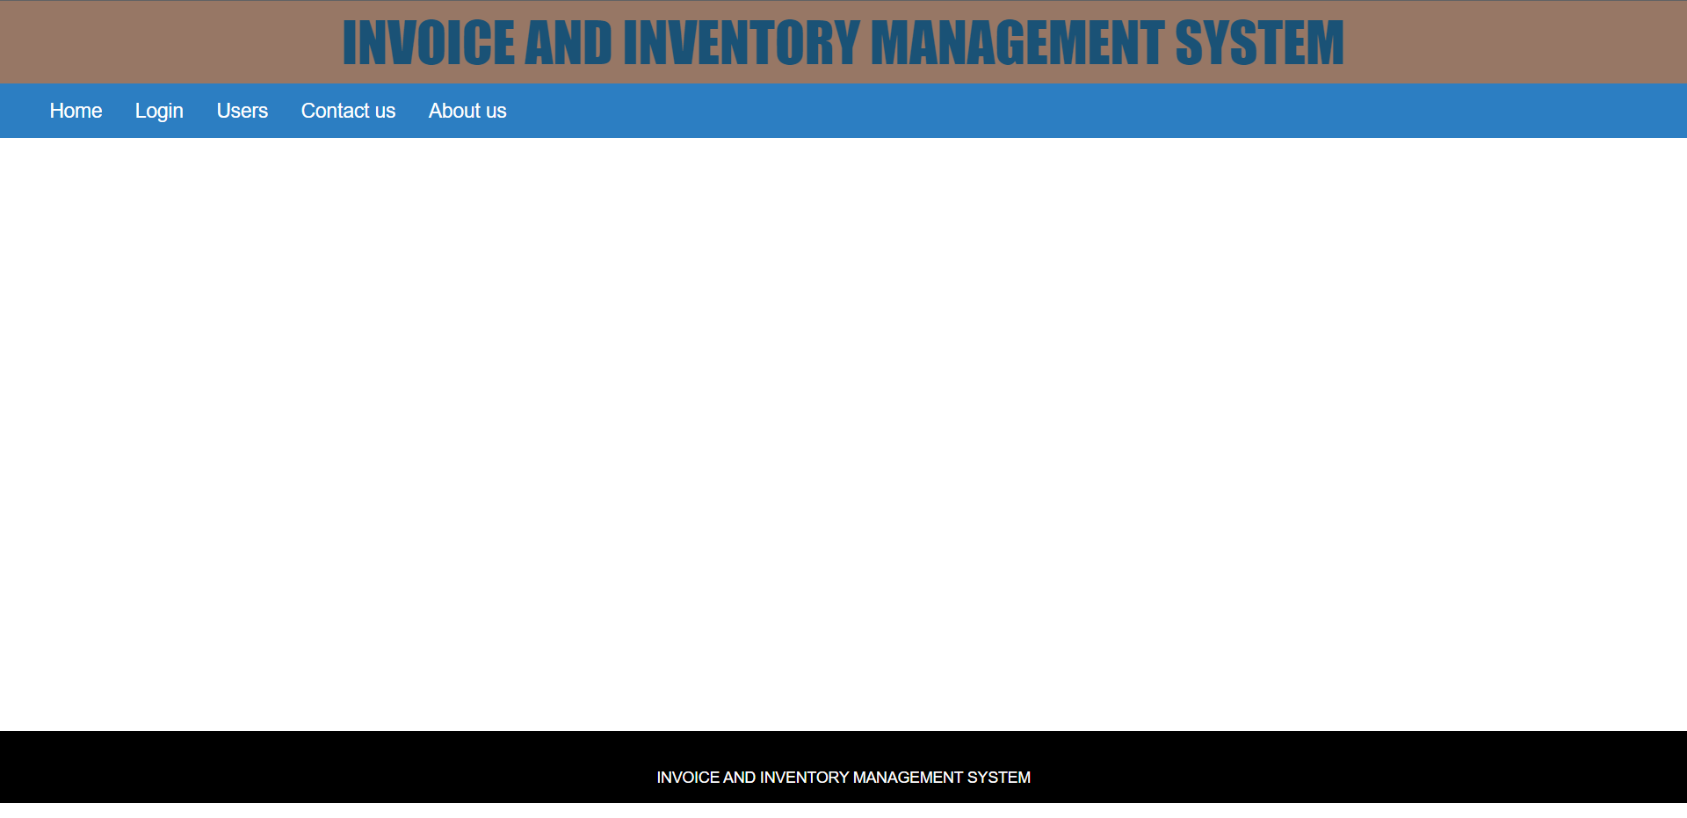

Figure 1.1 is the cover page for the application. In the above screenshot we have a navigation bar that contains Home, Login, Users, Contact us About us. As for now, we haven’t added anything to the Home page, In the future e, we may add functionalities based on our project requirements. Now coming to log-in and Users we will discuss those functionalities in depth later. Let us go for the Contact us page and About us page.

Figure 1.2 :

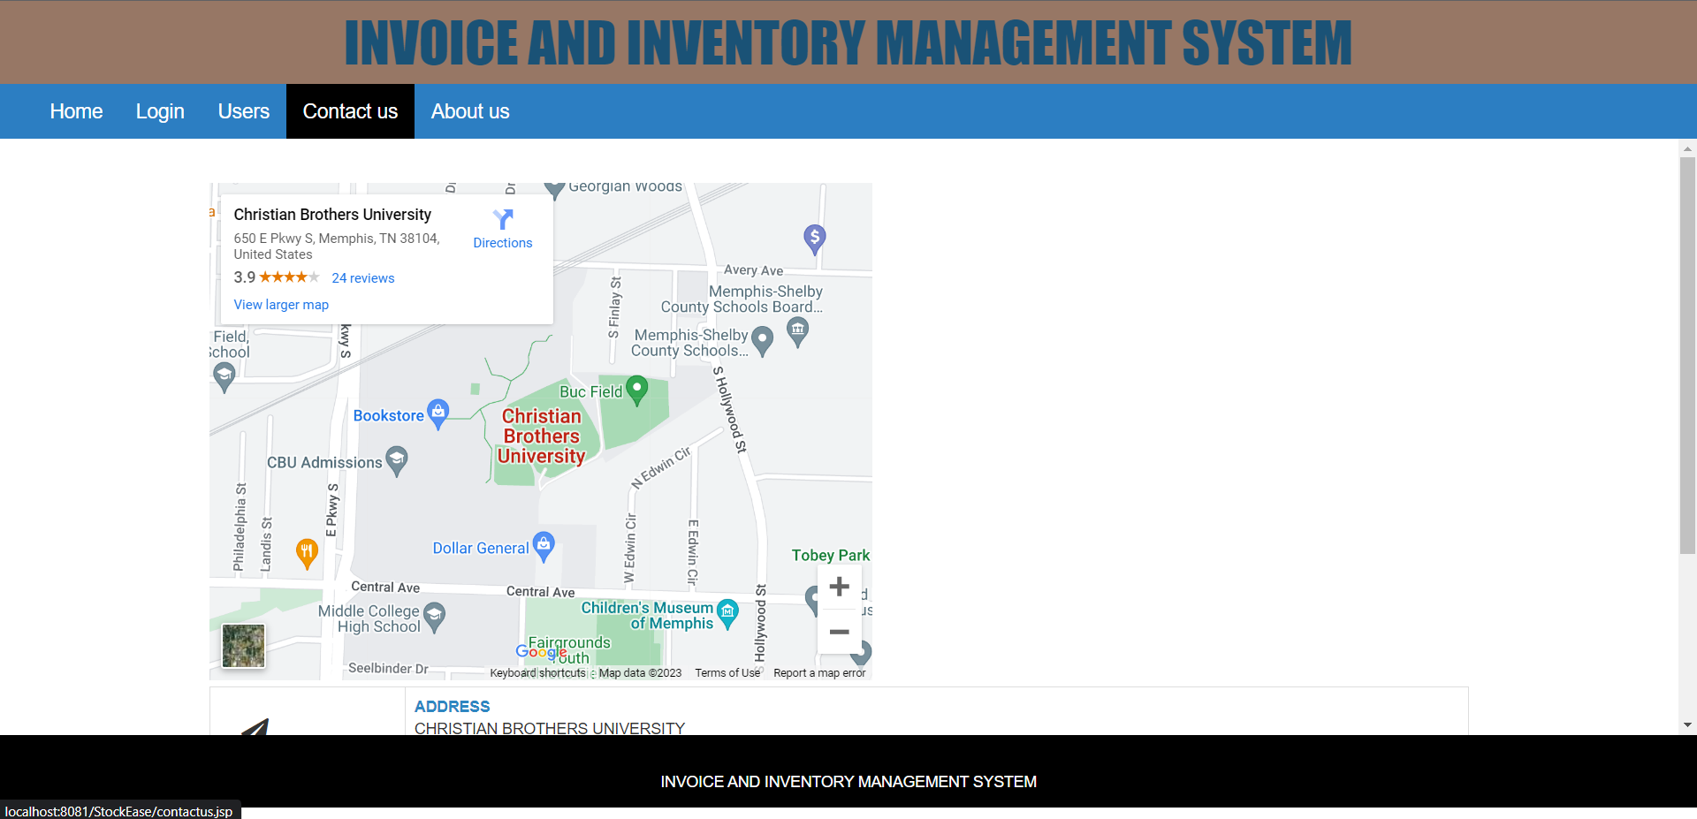

Figure 1.2.1 :

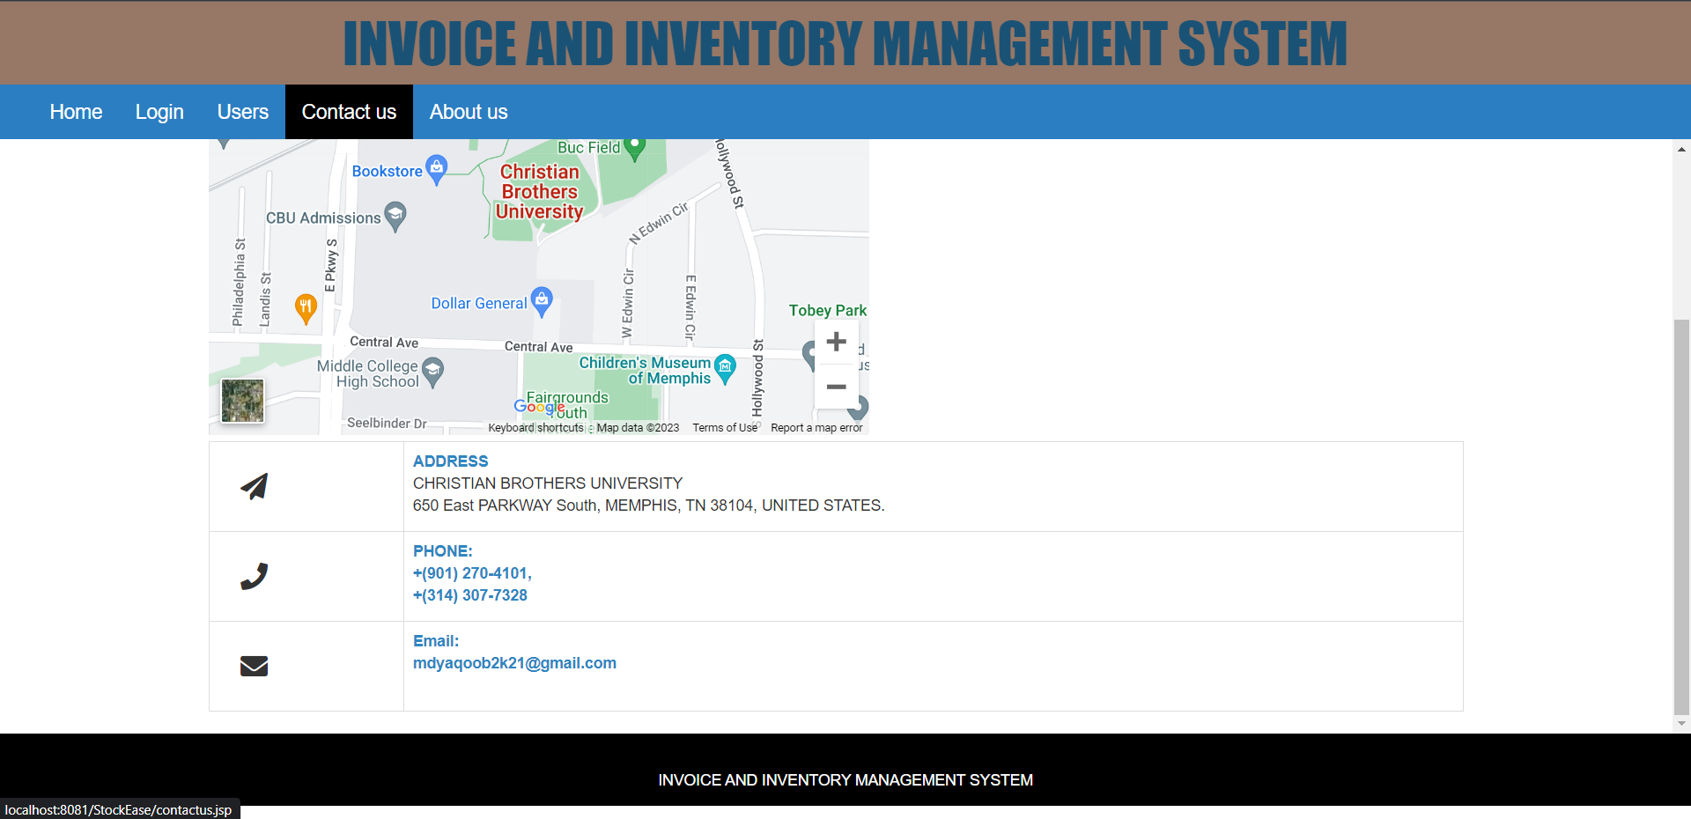

Figure 1.2 and figure 1.2.1 shows the contact us page for the application. We have added the map location to the project which we can change based on the requirements of the business. We can update the location of the business. And also have the address, contact numbers, and email ids. Now let us go for the about us page.

Figure 1.3 :

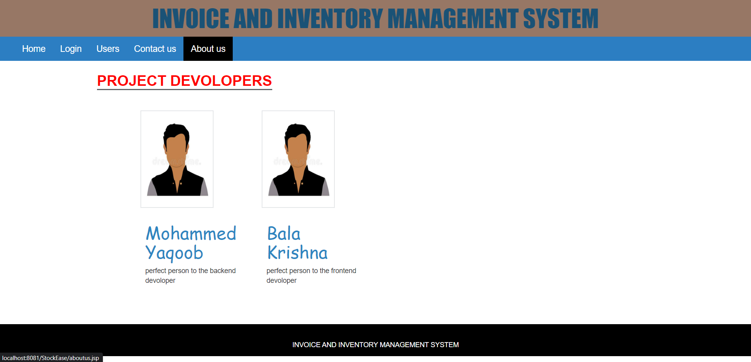

Figure 1.3 shows the about us page. Here we have added information about the developers who are involved in the project. Now let us understand deeply about login and users option on the home page.

Figure 1.4 :

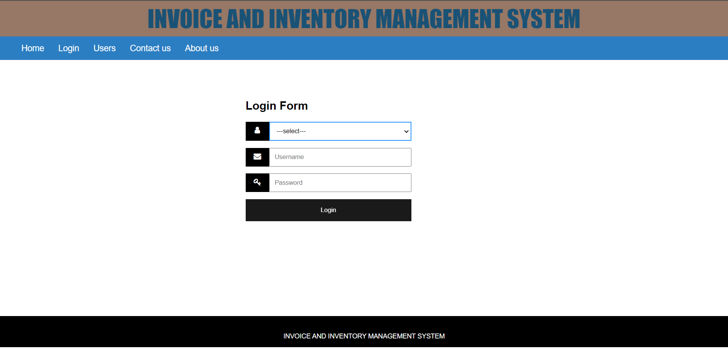

Figure 1.4.1 :

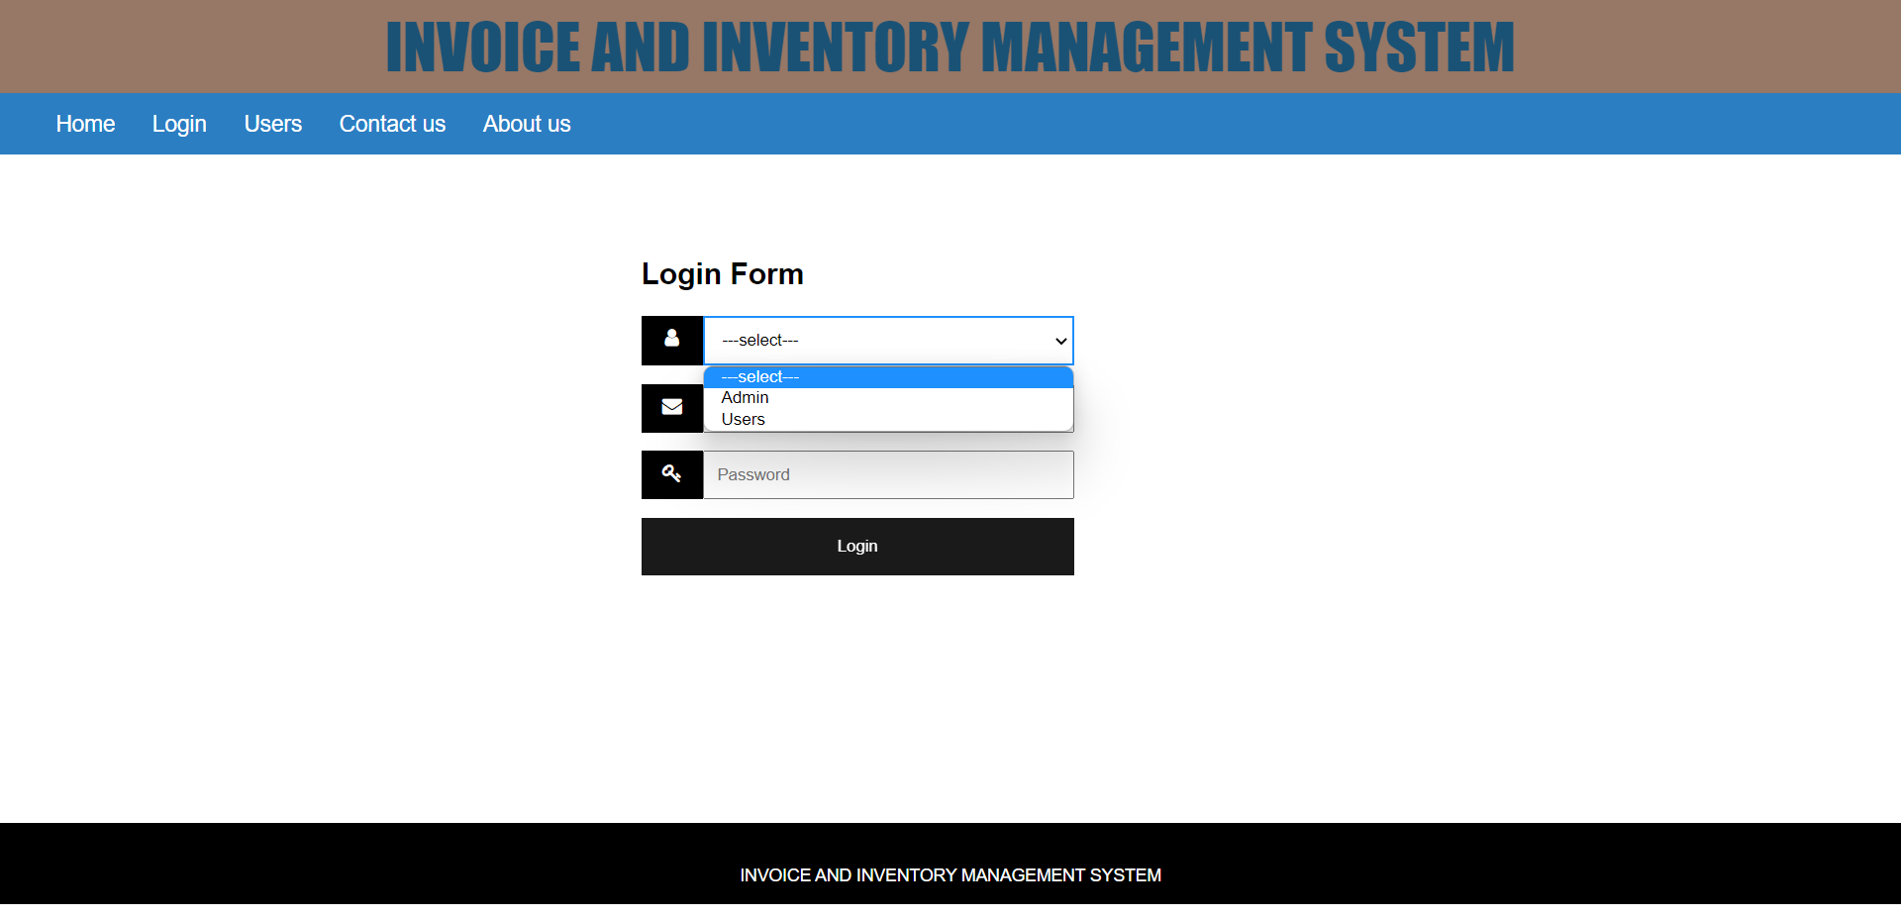

Figure 1.4.2 :

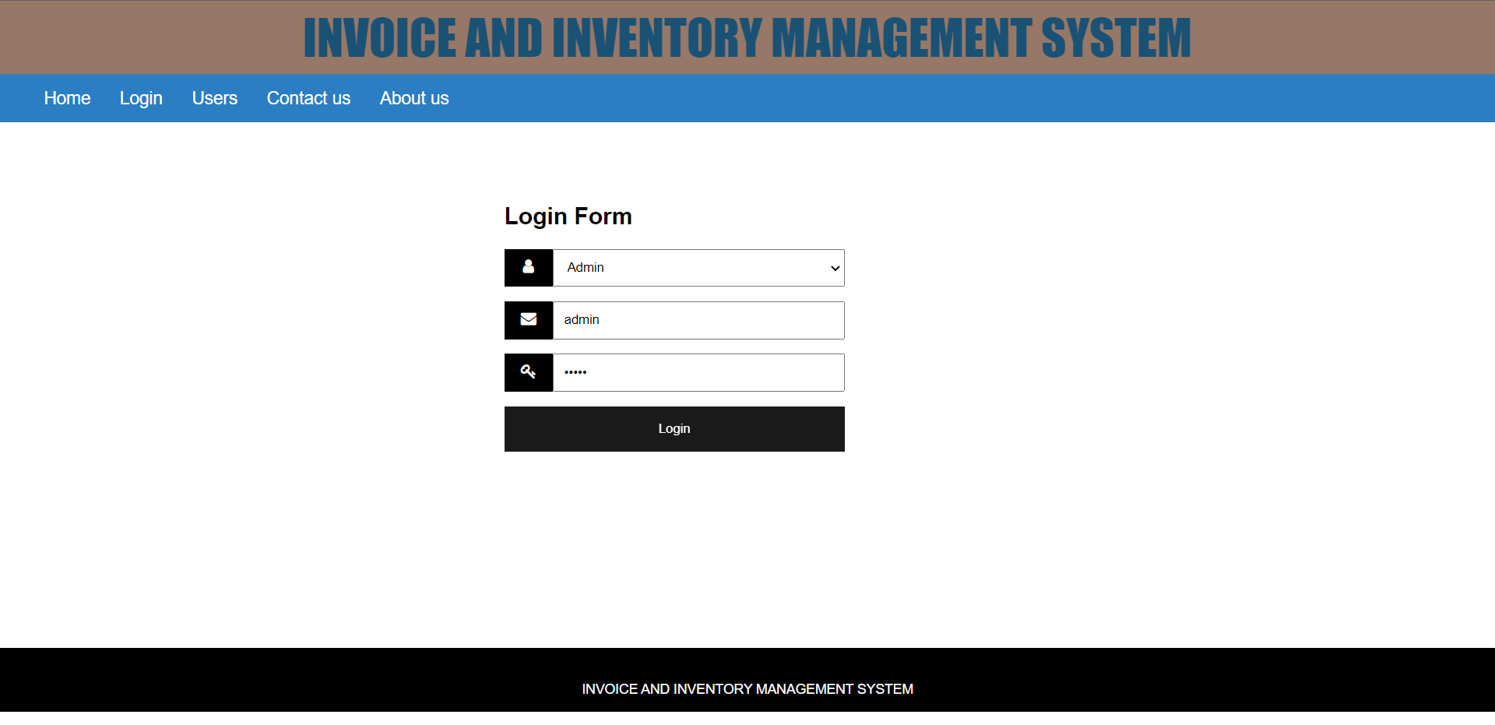

Figure 1.4, figure 1.4.1, and figure 1.4.2 show us the Login page for admin and how to log in with admin credentials. To log in with admin we should select admin from the drop-down list as shown in figure 1.4.1 and we should give a username and password which will be redirected to the Admin home page. Let us understand the functionalities of the admin home page later. Now let us go to the user’s option available in the navigation bar of the home page.

Figure 1.5 :

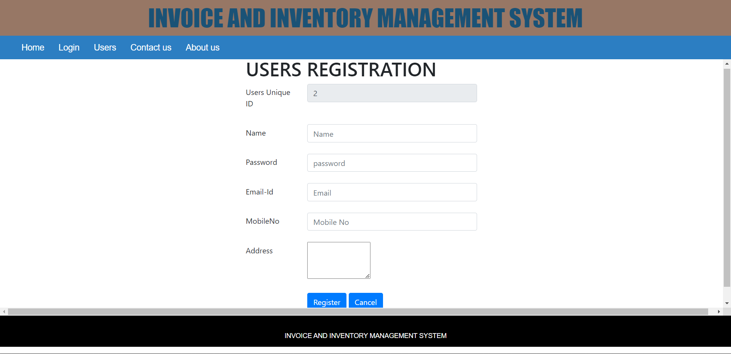

Figure 1.5 shows the user registration form where the user can enter the fields and click on register. After registration, the request will go to the admin. A user can log in with his credentials only if the admin accepts the request. Now we will see how the admin accepts the request. To accept the request of the user admin need to log in with admin credentials.

Figure 2.1 :

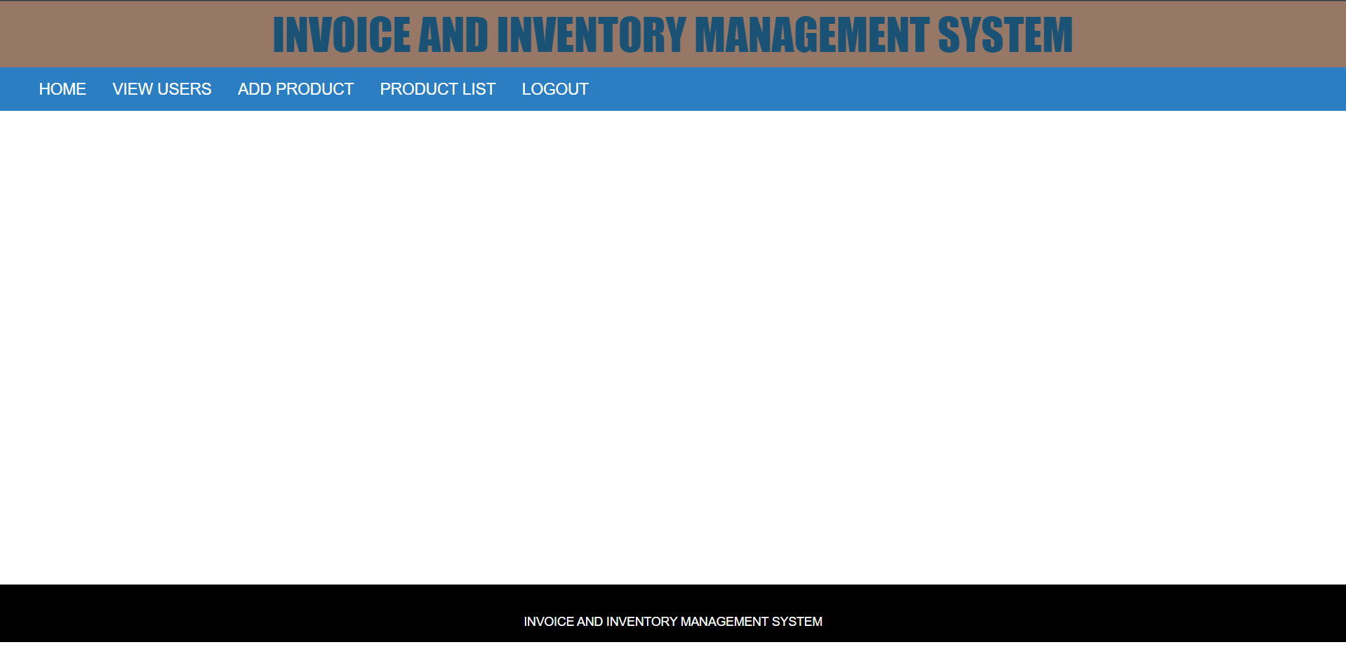

Figure 2.2 :

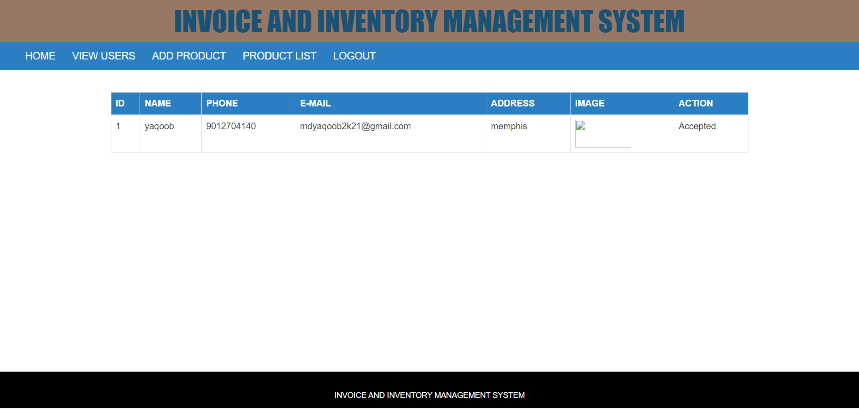

Figure 2.1 shows the admin home page after logging in with admin credentials. As for now home page is empty we will add functionalities in the future based on the requirements of the project. Figure 2.2 shows the view user functionality, If we click that we can see the requests of the users. In the action column, we will get pending, if we click it will change to Accepted. Now the user can be login with his credentials. We will understand how to log in with user credentials later. Now we will see how Add product functionality is working.

Figure 2.3 :

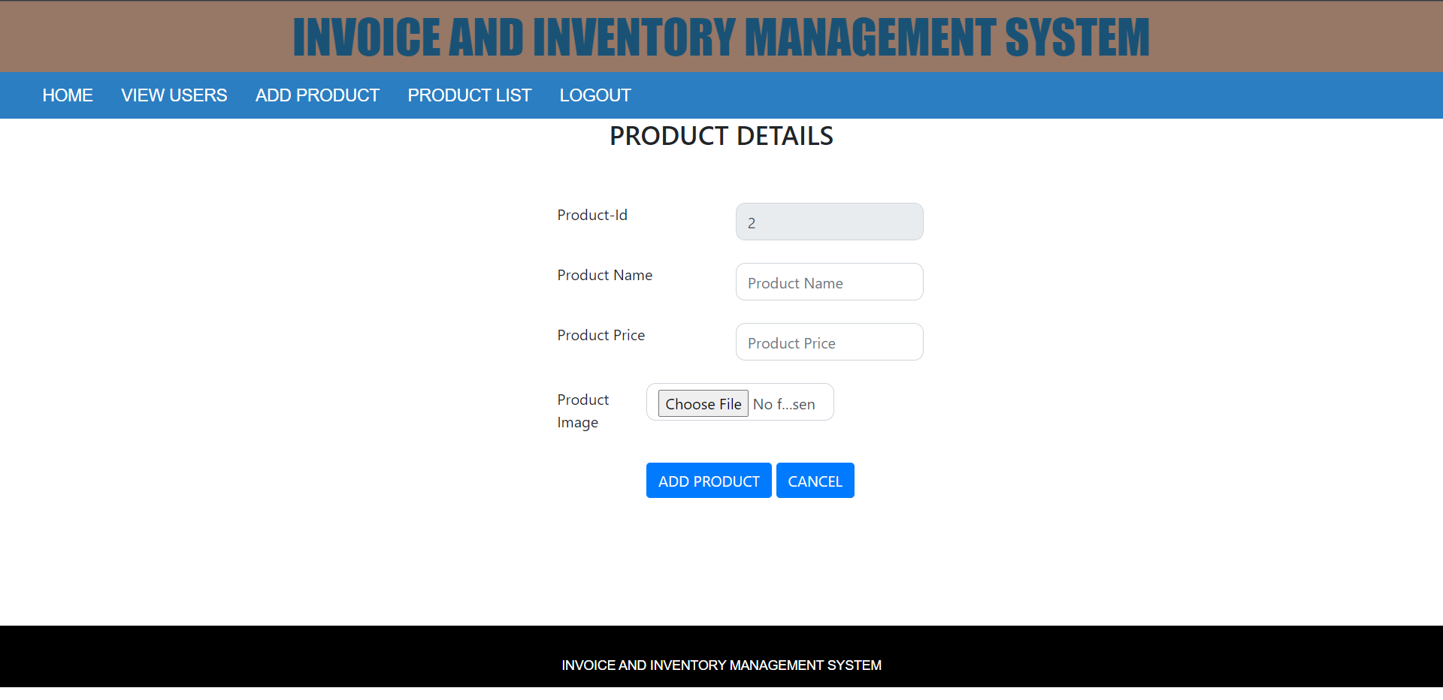

Figure 2.3 shows us the added product form on the admin home page. We can add products by filling out the form and clicking on add product button. And if we want to view the products we can click the on product list.

Figure 2.4 :

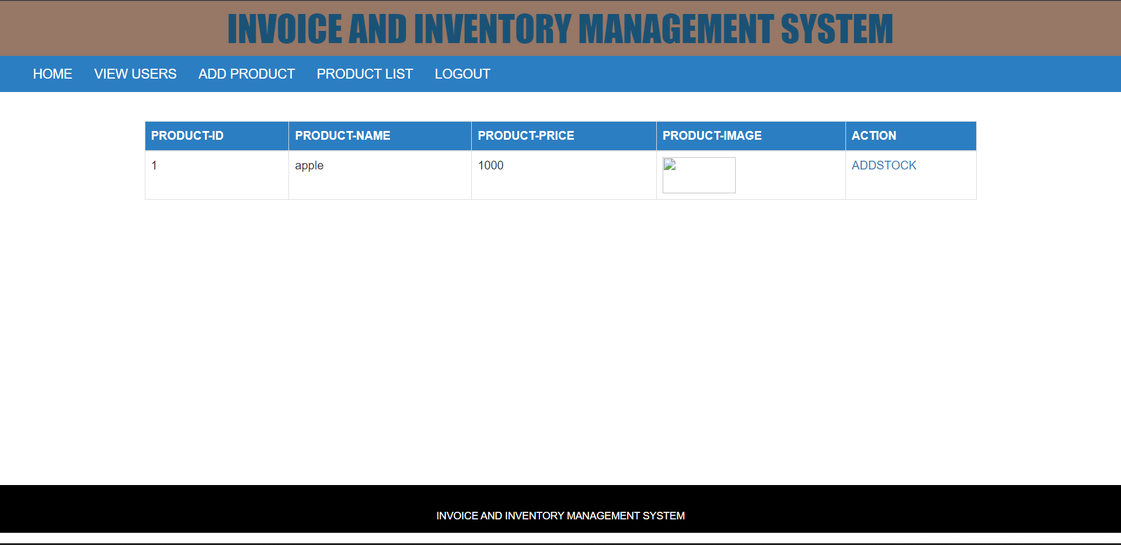

Figure 2.4 shows us the product list. It will display the list of products we have added. And we have a logout functionality that redirects to the home page of the application.

Figure 3.1 :

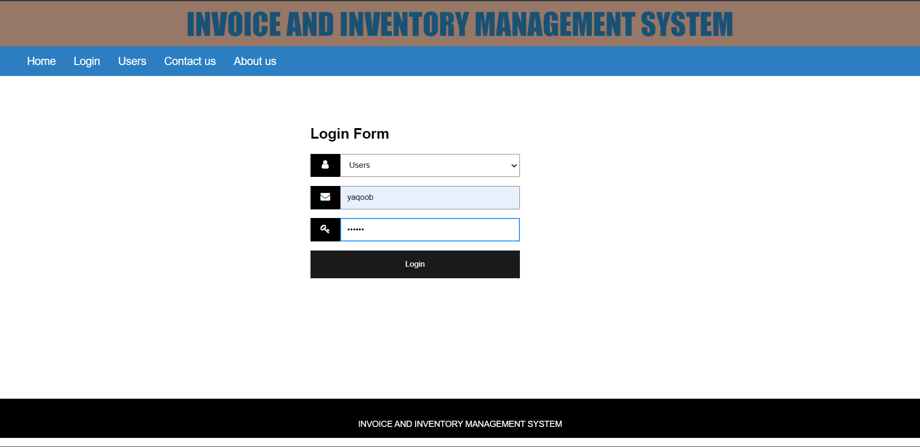

Figure 3.1 shows us how to log in with user credentials. We should select the user in the drop-down list and enter the username and password. It will redirect to the user’s home page.

Figure 3.2 :

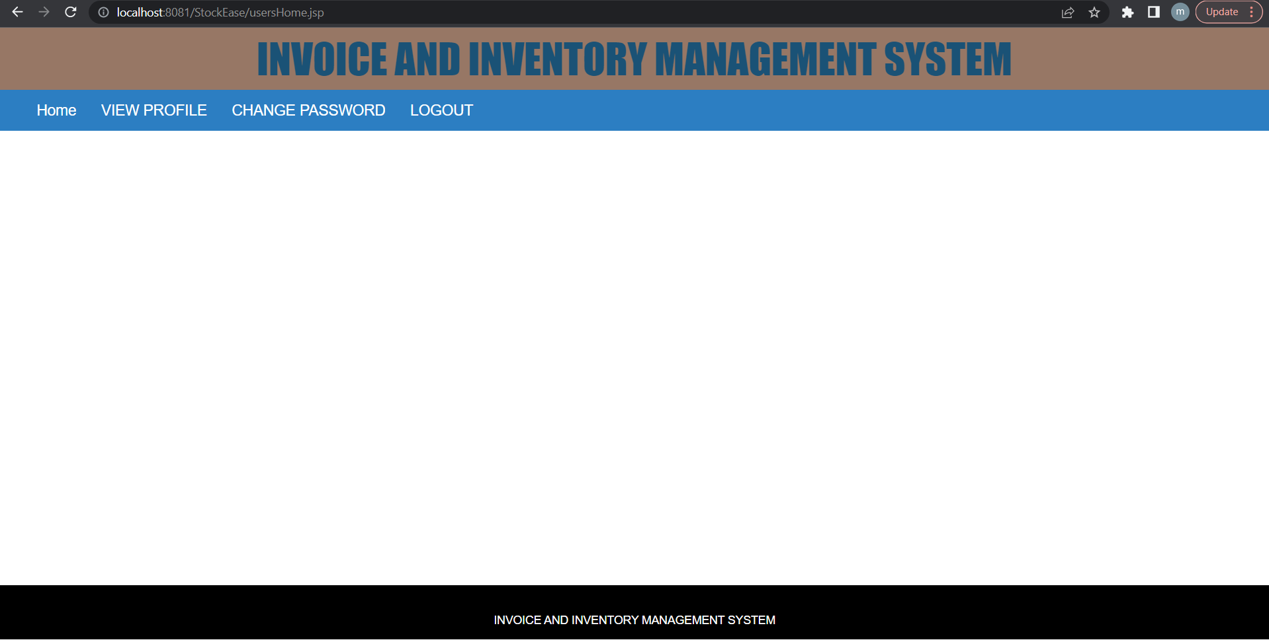

Figure 3.2 shows the user’s home page after login. As for now, we haven’t added anything to the home page, later we may add functionalities based on the project requirements.

Figure 3.3 :

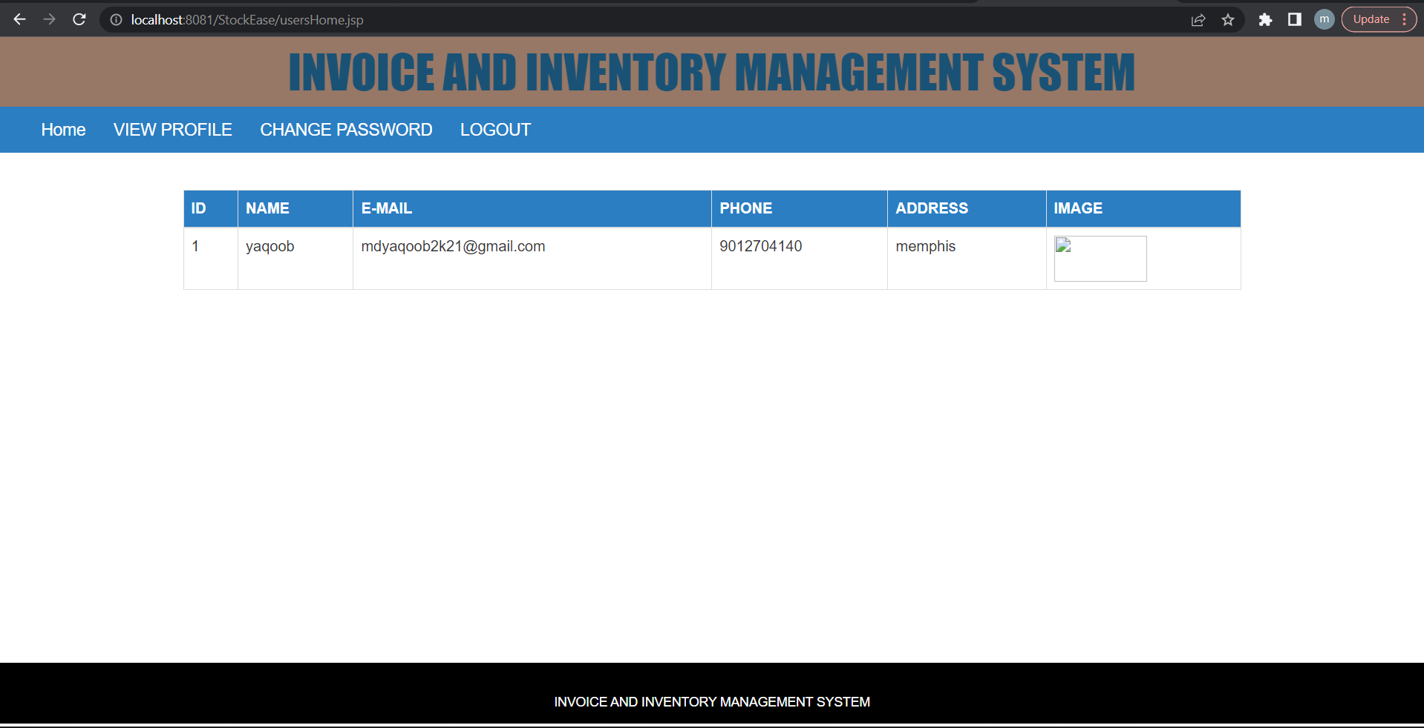

Figure 3.3 shows us the view profile option in the navigation bar. Here we can check the details of the user.

Figure 3.4 :

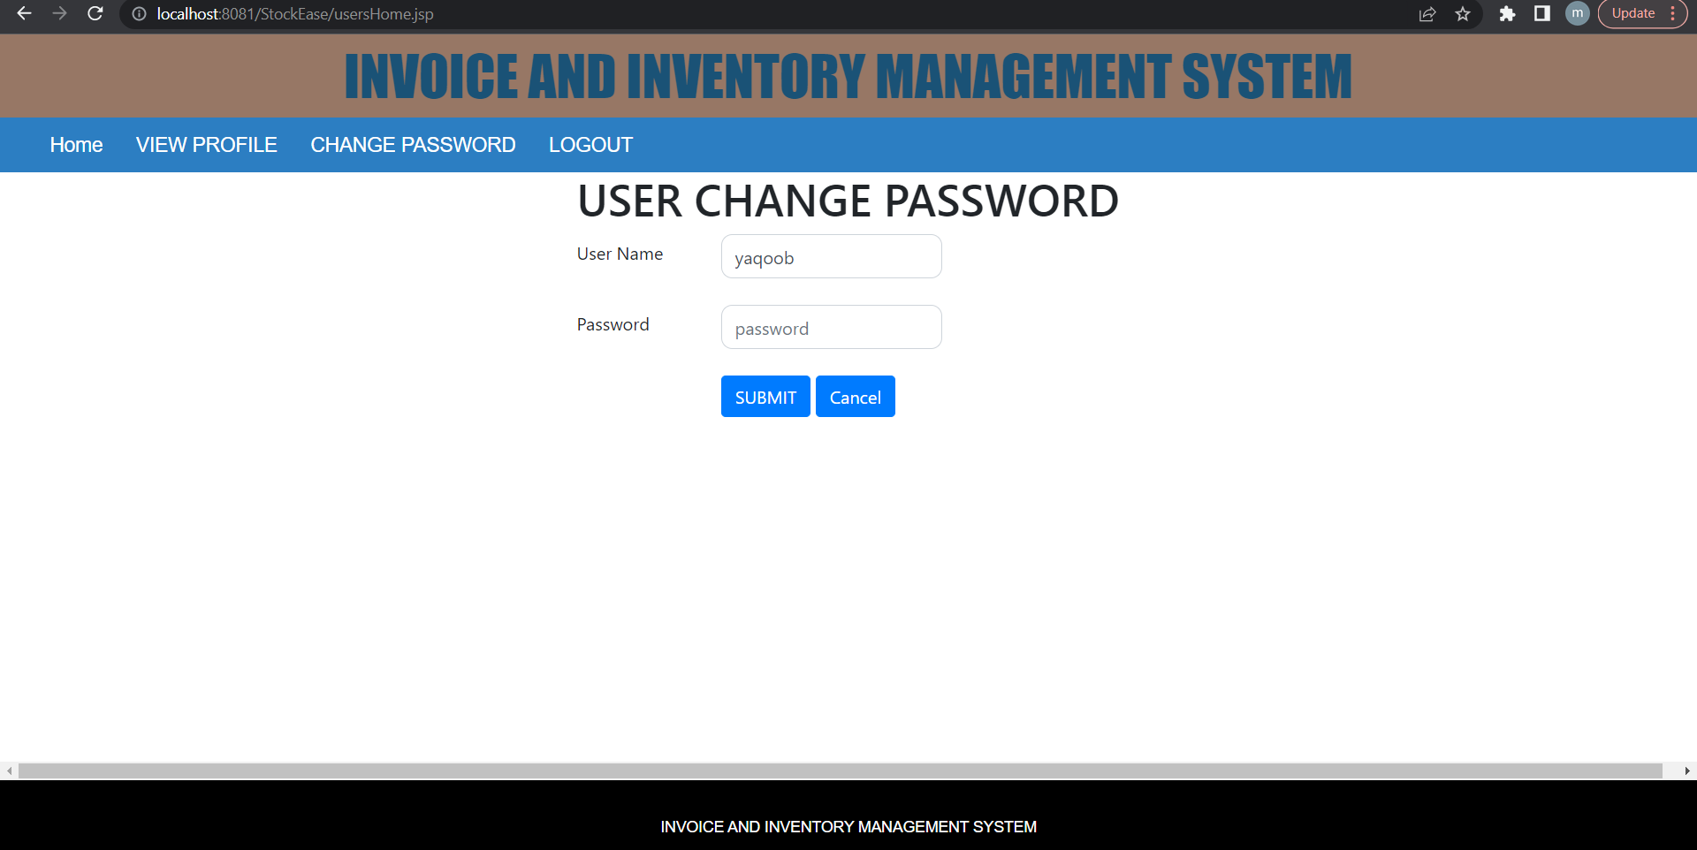

Figure 3.4 shows the change password functionality for the user. We can change the password for the user using this functionality. And we have a logout functionality for users. After clicking on logout it will redirect to the home page of the application.

1. Project Deployment
2. Conclusion
3. Reference